# MEGHNAD SAHA INSTITUTE OF TECHNOLOGY

*Nazirabad, P.O. - Uchhepota, Near URBANA Complex, Anandapur, Kolkata 700 150*

**BACHELOR OF COMPUTER APPLICATION**



LABORATORY NOTE BOOK

MAKAUT ODD SEMESTER 2023

PAPER NAME: COMPUTER NETWORKING LAB

PAPER CODE: BCAC592

STUDENT NAME: RUPAK SARKAR

ROLL NO: 31001221010

REGN. NO.: 213101001210001

YEAR: 3RD

SEMESTER: 5TH

SECTION: BCA

SESSION: 2021-2024



MEGHNAD SAHA INSTITUTE OF TECHNOLOGY

*Nazirabad, P.O. - Uchhepota, Near URBANA Complex, Anandapur, Kolkata 700 150*

## “LIST OF ASSIGNMENT/EXPERIMENT SUBMISSION DETAILS”

|  |  |  |  |  |  |
| --- | --- | --- | --- | --- | --- |
| **SL.**  **NO.** | **ASSIGNMENT / EXPERIMENT NAME** | **DATE OF ASSIGNMENT**  **/ EXPERIMENT DONE** | **DATE OF SUBMISSION** | **CHECKED BY** | **REMARKS**  **(ANY DEVIATION REGARDING SUBMISSION DATES, CONTENT, FORMAT, ETC)** |
| 1 | What is computer networking and computer internetworking. | 30/09/2023 | 30/09/2023 |  |  |
| 2 | Explain different data cables in computer networking. | 30/09/2023 | 30/09/2023 |  |  |
| 3 | Explain functions of Hub and Switches with diagram. | 30/09/2023 | 30/09/2023 |  |  |
|  |  |  |  |  |  |
|  |  |  |  |  |  |
|  |  |  |  |  |  |
|  |  |  |  |  |  |
|  |  |  |  |  |  |
|  |  |  |  |  |  |
|  |  |  |  |  |  |
|  |  |  |  |  |  |
|  |  |  |  |  |  |
|  |  |  |  |  |  |
|  |  |  |  |  |  |
|  |  |  |  |  |  |

OBSERVATIONS / COMMENTS ON THE OVERALL PERFORMANCE:

Signature in full with date

Faculty / Technical Assistant

ASSIGNMENT 1

Q.1. What is computer networking and computer internetworking?

A computer network is a system that connects numerous independent computers in order to share information and resources. The integration of computers and other different devices allows users to communicate more easily.

A computer network is a collection of two or more computer systems that are linked together. A network connection can be established using either ether cable or wireless media. Hardware and software are used to connect computers and tools in any network.

A computer network consists of various kinds of nodes. Servers, networking hardware, personal computers and other specialized or general-purpose hosts can all be nodes in a computer network. Host names and network addresses are used to identify them.

**Internetworking** is the practice of interconnecting multiple computer networks, such that any pair of hosts in the connected networks can exchange messages irrespective of their hardware-level networking technology. The resulting system of interconnected networks are called an *internetwork*, or simply an *internet*.

The most notable example of internetworking is the Internet, a network of networks based on many underlying hardware technologies. The Internet is defined by a unified global addressing system, packet format, and routing methods provided by the Internet Protocol.

The term *internetworking* is a combination of the components *inter* (between) and *networking*. An earlier term for an internetwork is **catenet**, a short-form of *(con)catenating networks*.

To enable communication, every individual network node or phase is designed with a similar protocol or communication logic, that is Transfer Control Protocol (TCP) and Internet Protocol (IP). Once a network communicates with another network having constant communication procedures, it is called internetworking. Internetworking was designed to resolve the matter of delivering a packet of information through many links.

Q.2. Explain

a) RJ45

b) Networking Cables (CAT-5, CAT-6, UTP)

Ans)

RJ45 Connector:

RJ45 is the acronym for Registered Jack 45. RJ45 connector is an 8-pin jack

used by devices to physically connect to Ethernet based local area networks

(LANs). Ethernet is a technology that defines protocols for establishing a LAN.

The cable used for Ethernet LANs are twisted pair ones and have RJ45 connector

pins at both ends. These pins go into the corresponding socket on devices and

connect the device to the network.

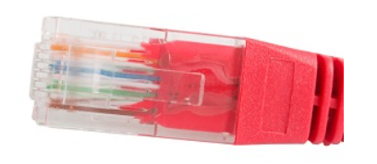

**CAT-5:** Cat 5 is an abbreviation used for Category 5 cables. This cable constitutes of twisted wires and is used for networking. Since 2001, the Cat 5e variant of this cable has been used in computer networks. It has a performance of 100 MHz and is mostly used for establishing Ethernet connections over twisted cables. It can be used up to 2.5 GBase-T, but it is mostly used to run at 1000Base-T speeds.

They are also used to transmit signals over telephones and videos. However, they mostly connect using punch-down blocks and modular connectors. Most of the cables are unshielded; they do not have any additional insulation coating. They largely rely on the balanced line twisted pair design and differential signalling to ensure noise rejection.

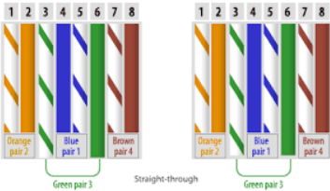

The specification for Cat 5 cables is defined under the ISO/IEC 11801, IEC 61156, and EN 50173. Its standard specification was defined under ANSI/TIA/EIA-568-A. It clearly defines the character of the cable and the requirement to work efficiently. The characteristics are defined based that the performance at 100 MHz frequencies.

The Cat 5 cable is available in both solid conductor and stranded forms. The stranded form of the cable is used when the user wants more flexibility and bending without breaking. The patch cables are stranded. While the solid conductor cables are used where the user requires permanent wiring, they have a solid core though less flexible. They are comparatively more durable. The category of the cable can be determined by checking the printing on the cable's jacket.

**CAT-6:** **Category 6 cable** (**Cat 6**) is a standardized twisted pair cable for Ethernet and other network physical layers that is backward compatible with the Category 5/5e and Category 3 cable standards.

Cat 6 must meet more stringent specifications for crosstalk and system noise than Cat 5 and Cat 5e. The cable standard specifies performance of up to 250 MHz, compared to 100 MHz for Cat 5 and Cat 5e.

Whereas Category 6 cable has a reduced maximum length of 55 metres (180 ft) when used for 10GBASE-T, **Category 6A cable** is characterized to 500 MHz and has improved alien crosstalk characteristics, allowing 10GBASE-T to be run for the same 100-metre (330 ft) maximum distance as previous Ethernet variants.

**Unshielded Twisted Cable:**

UTP is used in computer and telecommunication mediums. Its frequency range is suitable for transmitting both data and voice via a UTP cable. Therefore, it is widely used in the telephone, computers. It is a pair of insulated copper wires twisted together to reduce noise generated by external interference. It is a wire with no additional shielding, like aluminium foil, to protect its data from the exterior.

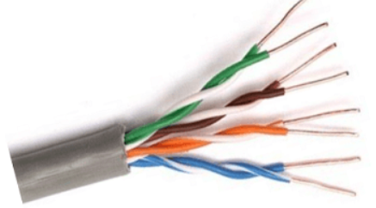

Q.3. Explain functions of HUB and Switches with Diagram.

Ans)

Hub: A hub is a physical layer networking device which is used to connect multiple devices in a network. They are generally used to connect computers in a LAN. A hub has many ports in it. A computer which intends to be connected to the network is plugged in to one of these ports. When a data frame arrives at a port, it is broadcast to every other port, without considering whether it is destined for a particular destination or not.

Applications of Hub

The important applications of a hub are given below:

o Hub is used to create small home networks.

o It is used for network monitoring.

o They are also used in organizations to provide connectivity.

o It can be used to create a device that is available thought out of the network.

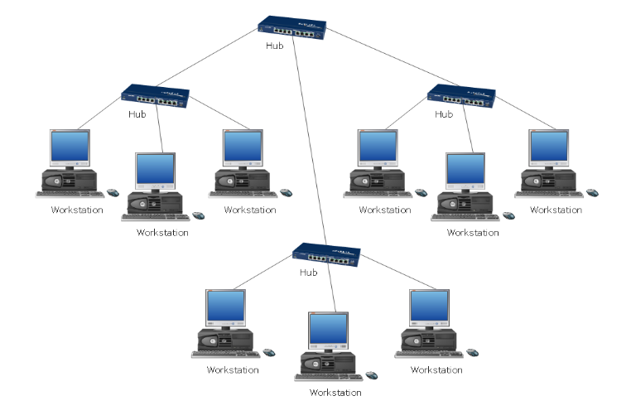

Switch:

A switch is a data link layer networking device which connects devices in a

network and uses packet switching to send and receive data over the network.

Like a hub, a switch also has many ports, to which computers are plugged in.

However, when a data frame arrives at any port of a network switch, it examines

the destination addresses and sends the frame to the corresponding device(s).

Thus, it supports both unicast and multicast communications.

Features of Switch:

Here, are important features of switch:

* It is Datalink layer device (Layer 2)
* It works with fixed bandwidth
* It maintains a MAC address table
* Allows you to create virtual LAN
* It works as a multi-port bridge
* Mostly comes with 24 to 48 ports
* Supports half and full-duplex transmission modes

